BIRLA INSTITUTE OF TECHNOLOGY & SCIENCE, PILANI
Work Integrated Learning Programmes Division
ASSIGNMENT DOCUMENTATION
SOFTWARE SYSTEM SPECIFICATION & ARCHITECTURAL MODELING
ASSIGNMENT DOCUMENTATION
SOFTWARE SYSTEM SPECIFICATION & ARCHITECTURAL MODELING

Item | Details
Course | SS ZG562: Software Engineering and Management
Project Title | Smart Construction Site Material & Inventory Management System
Group Name | Site-Sathi
Members | ANKIT KUSHWAHA (2026ns12135)  GADAMSETTY V SAI MANOJ KUMAR (2025mt12100)
Faculty / Instructor | BHUPINDER SINGH PAWA
Submission Date | 07 October 2026

Submitted as a group assignment

Table of Contents
1. Executive Summary, Case Study and Scope
2. Business Goals and Non-Functional Requirements
3. Use-Case Model
4. Use-Case Prioritization
5. Significant Use-Case Specifications
6. Software Architecture
7. Domain Class Modeling
8. Behavioral Modeling
9. Requirements Traceability and Class-Operation Mapping
10. Conclusion
11. References

1. Executive Summary, Case Study and Scope
Civil construction projects frequently experience material wastage, theft, stockouts, manual data-entry errors and procurement delays. These issues are intensified across multiple construction sites where connectivity may be intermittent and material records are maintained on paper. The Smart Construction Site Material & Inventory Management System digitizes material requests, purchase orders, delivery verification, inventory updates and reorder decisions in one auditable workflow.
Target Indicator | Target
Material wastage and theft | 20% reduction within six months
Stockout-induced work stoppages | 35% reduction
Purchase-order approval to dispatch | Less than four hours
Physical-to-digital inventory accuracy | 98% match

1.1 In-Scope Functions
- Material requisition and purchase-order management.
- Supplier and purchase-order status tracking.
- QR-code delivery-docket verification.
- Recording of delivered quantity, batch number and storage yard.
- Inventory balance updates and audit logging.
- Low-stock detection, reorder recommendations and alerts.
- Offline transaction capture using encrypted SQLite storage.
- Automatic synchronization after network restoration.
- Photo evidence for weighbridge slips and quality documents.
- Role-based access for Site Engineers, Site Managers, Suppliers and Project Directors.

1.2 Out-of-Scope Functions
- Payroll and employee attendance management.
- Complete accounting and financial-ledger management.
- Construction design and structural analysis.
- Fleet maintenance and vehicle tracking.
- Supplier payment processing.
- Automated physical movement of material inside the site.

1.3 Assumptions
- Each construction site has a unique site identifier.
- Materials have configured minimum-stock and reorder quantities.
- Approved suppliers provide valid purchase-order information.
- Site Engineers have mobile devices capable of QR scanning.
- Site Managers are authorized to approve purchase orders.

2. Business Goals and Non-Functional Requirements
Goal ID | Business Objective | Target Impact / Metric
BG-01 | Material Wastage Reduction | Reduce raw-material wastage, spoilage and theft by 20% within six months.
BG-02 | Downtime Prevention | Decrease stockout-induced work stoppages by 35% through reorder alerts.
BG-03 | Procurement Efficiency | Reduce approval-to-dispatch lead time from 48 hours to less than four hours.
BG-04 | Inventory Reconciliation | Achieve 98% agreement between physical audits and digital inventory logs.

NFR ID | Quality Attribute | Specification and Verification Criterion
NFR-01 | Availability | Backend APIs shall maintain 99.9% uptime during operational hours (06:00-22:00).
NFR-02 | Performance | Stock-balance queries shall respond within 2 seconds under 500 concurrent users.
NFR-03 | Offline Synchronization | SQLite shall store up to 1,000 offline transactions and synchronize within 30 seconds of reconnection.
NFR-04 | Security and Integrity | TLS 1.3 in transit, AES-256 local storage and role-based access control.
NFR-05 | Usability | High-contrast field UI with touch targets of at least 48 px for outdoor glove usage.

3. Use-Case Model
The use-case model defines the interaction between operational actors and the system boundary.
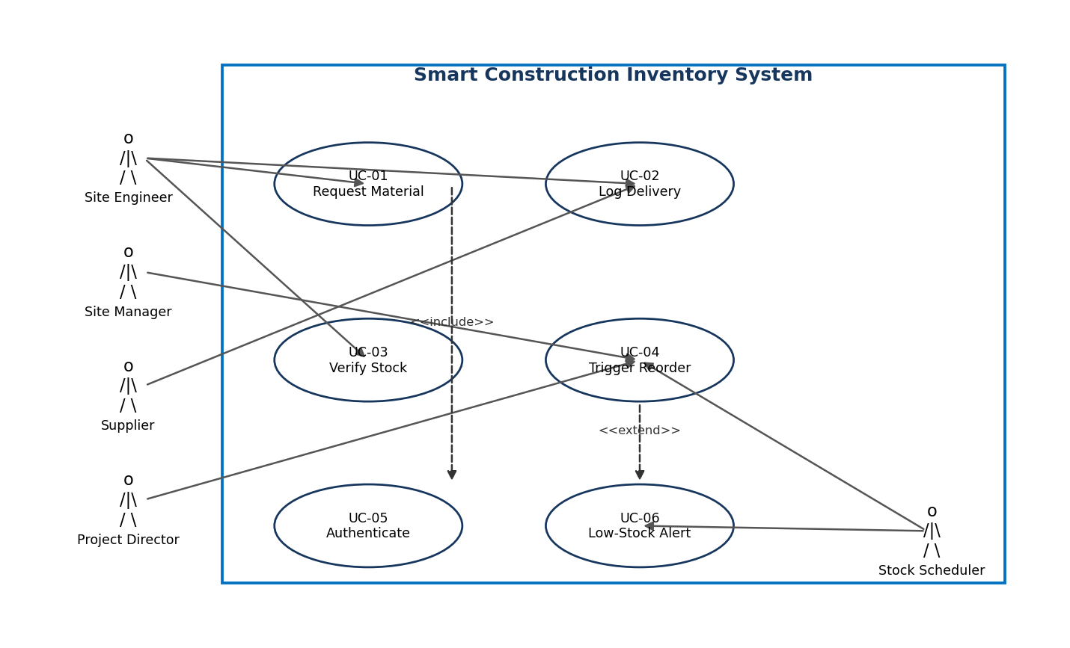
Figure 1. Use-Case Diagram and System Boundary
Actor | Responsibility
Site Engineer | Raises requests, records deliveries and verifies physical shipments.
Site Manager | Reviews stock, approves purchase orders and handles exceptions.
Supplier | Acknowledges purchase orders and dispatches material.
Project Director | Provides second approval for high-value purchase orders.
Stock Scheduler | Automatically checks thresholds and initiates reorder recommendations.

4. Use-Case Prioritization
MoSCoW prioritization is used to align implementation sequencing with business value and risk.
Priority | Use Case | Rationale | Release
Must Have | UC-05 Authenticate User | Security baseline and RBAC. | Sprint 1
Must Have | UC-02 Log Material Delivery | Core process for receipt and inventory update. | Sprint 1
Must Have | UC-03 Verify Stock Level | Maintains accurate stock information. | Sprint 1
Must Have | UC-04 Trigger Reorder | Prevents stockouts and site delays. | Sprint 1
Should Have | UC-01 Request Material | Automates internal approval workflow. | Sprint 2
Should Have | UC-06 Low-Stock Alert | Provides proactive notification. | Sprint 2
Could Have | Supplier Performance Rating | Enables future supplier analytics. | Sprint 3

Use Case | Primary Actor | Supporting Actors
UC-01 Request Material | Site Engineer | Site Manager
UC-02 Log Material Delivery | Site Engineer / Gatekeeper | Supplier
UC-03 Verify Stock Level | Site Engineer | Stock Scheduler
UC-04 Trigger Reorder | Stock Scheduler / Site Manager | Supplier, Project Director
UC-05 Authenticate User | All users | Authentication Service
UC-06 Low-Stock Alert | Stock Scheduler | Site Manager

5. Significant Use-Case Specifications

5.1 UC-02: Log Material Delivery
Template Field | Specification
Goal | Record and verify a material delivery and update the site inventory.
Primary Actor | Site Engineer / Gatekeeper
Scope and Level | Smart Construction Inventory System; user-goal level.
Trigger | A supplier shipment arrives at the construction-site gate.
Preconditions | User is authenticated; purchase order exists in Dispatched state or local cache.
Main Success Scenario | 1. Select Receive Delivery. 2. Scan QR docket or enter PO ID. 3. Display PO details. 4. Enter quantity, batch and yard. 5. Attach photo. 6. Validate, create receipt, update inventory and mark PO Delivered.
Alternate Flows | Partial delivery changes PO to Partially Delivered. Quality defect creates a rejection slip and blocks stock addition.
Exception Flow | If offline, save the encrypted transaction locally and synchronize after reconnection.
Postconditions | Inventory balance and DeliveryReceipt are updated; audit log stores user, time and GPS.
Business Rules | Delivered quantity cannot exceed 105% of PO quantity without manager approval. Weighbridge photo is mandatory for aggregate deliveries above five metric tons.
Special Requirements | QR scan, offline operation, photo evidence, NFR-03 synchronization and NFR-04 security.

5.2 UC-04: Trigger Reorder and Process Purchase Order
Template Field | Specification
Goal | Create and process a purchase order when available stock reaches the safety threshold.
Primary Actor | Stock Scheduler / Site Manager
Scope and Level | Smart Construction Inventory System; system-goal level.
Trigger | Inventory verification detects stock less than or equal to the minimum threshold.
Preconditions | Safety stock and reorder quantity are configured; an approved supplier catalogue exists.
Main Success Scenario | 1. Detect low stock. 2. Create draft PO. 3. Notify manager. 4. Manager verifies budget and approves. 5. Transmit PO to supplier. 6. Supplier acknowledges and dispatches.
Alternate Flows | Manager adjusts quantity; Engineer requests a manual reorder because of an impending weather delay.
Exception Flow | Supplier returns Capacity Exceeded; system alerts manager and suggests a secondary approved supplier.
Postconditions | PO is Approved or Dispatched and the approval audit record is stored.
Business Rules | Orders above $50,000 require Site Manager and Project Director approval. Auto-reorder is suppressed when yard capacity is above 90%.
Special Requirements | Dual approval, audit trail, supplier fallback and four-hour approval-to-dispatch target.

6. Software Architecture
A three-tier layered client-server architecture separates presentation, business logic and persistence concerns. This supports mobile field use, offline operation, maintainability and independent scaling.
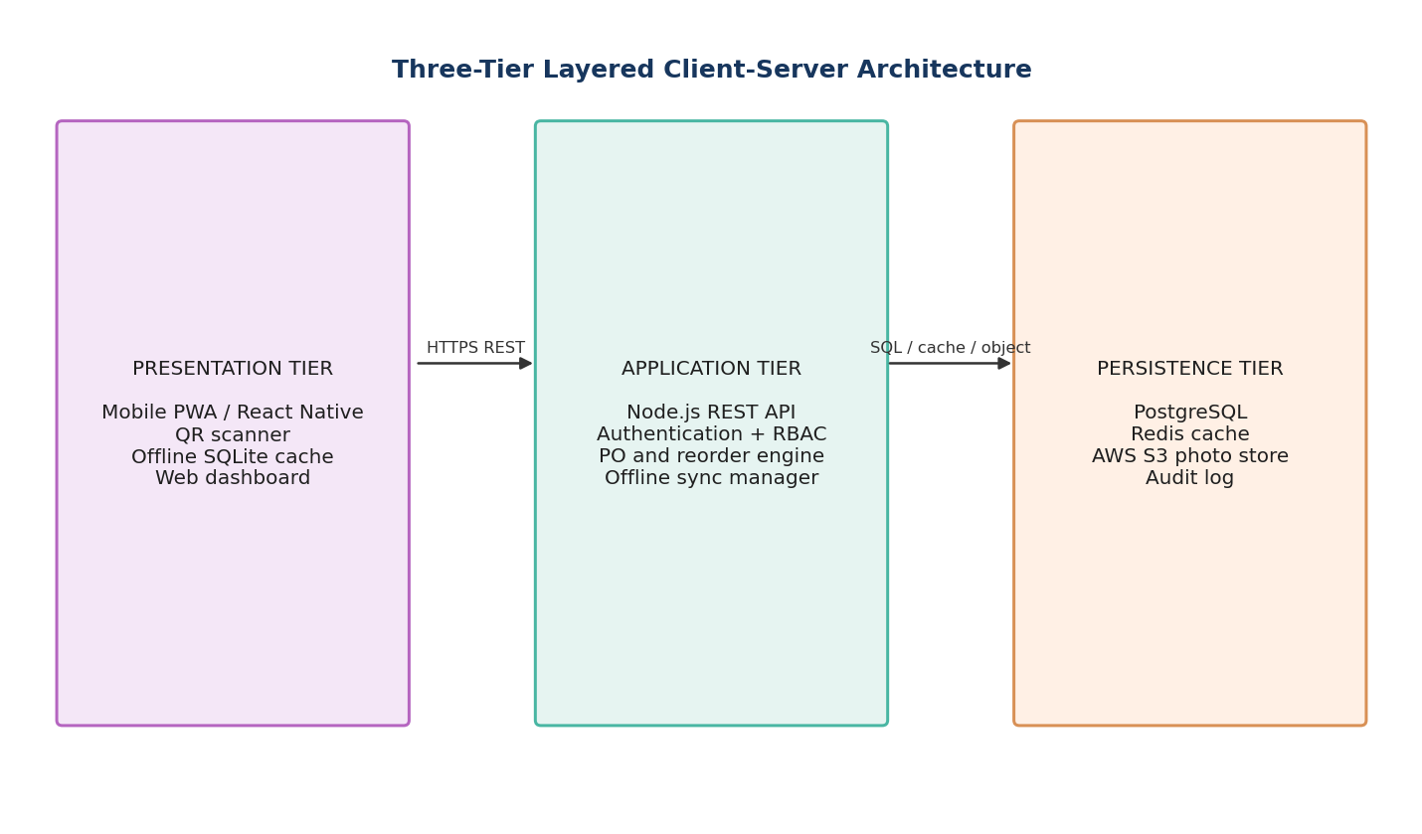
Figure 2. Three-Tier Layered Architecture and Data Flow
Layer | Technology | Responsibilities
Presentation / Client | React Native PWA, SQLite | QR scanning, high-contrast field UI, local transaction caching.
Application / Middle | Node.js REST API, Express, sync engine | Authentication, RBAC, business rules, reorder logic and synchronization.
Persistence / Backend | PostgreSQL, Redis, AWS S3 | Domain entities, stock cache, audit records and photo evidence.

Quality Attribute | Architectural Response
Availability | Redundant API deployment and operational monitoring.
Performance | Redis cache for frequently accessed stock balances.
Security | TLS 1.3, JWT authentication, RBAC and encrypted local storage.
Offline Support | SQLite transaction queue and reconnect synchronization.
Auditability | User identity, timestamps, GPS coordinates and approval history.

7. Domain Class Modeling
The domain model represents site managers, suppliers, materials, purchase orders, delivery receipts and the inventory transaction ledger.
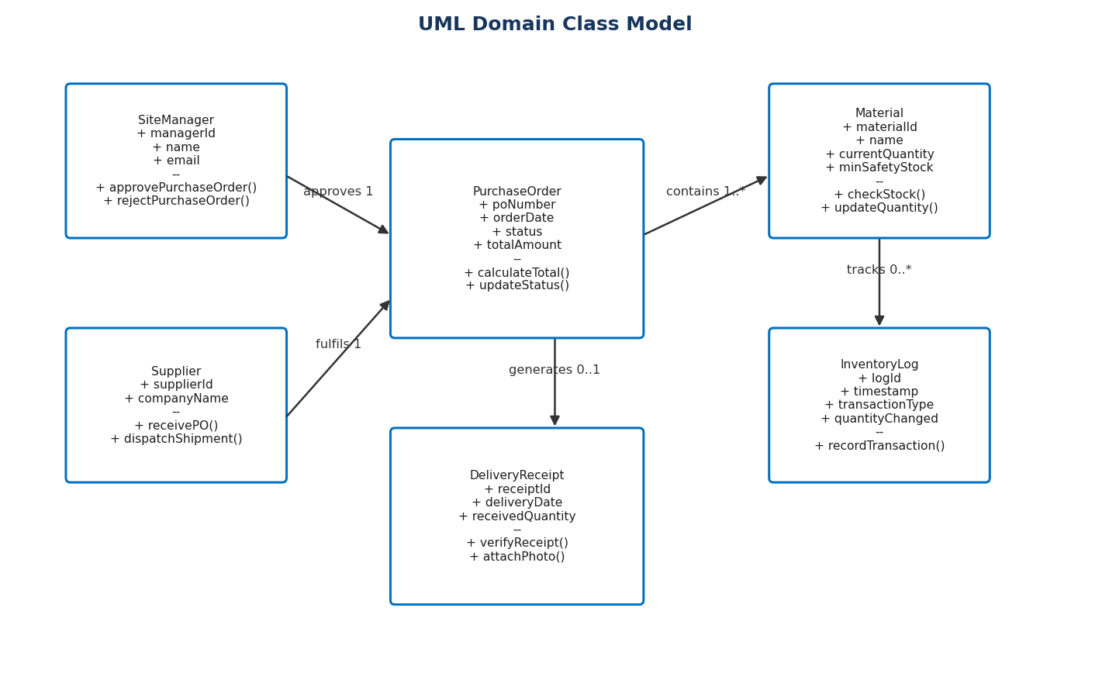
Figure 7. UML Domain Class Model
Class | Key Attributes | Operations
SiteManager | managerId, name, email | approvePurchaseOrder(), rejectPurchaseOrder(), adjustOrderQuantity()
Supplier | supplierId, companyName | receivePurchaseOrder(), acknowledgePurchaseOrder(), dispatchShipment()
PurchaseOrder | poNumber, orderDate, status, totalAmount | calculateTotal(), updateStatus(), requestDualApproval()
Material | materialId, name, currentQuantity, minSafetyStock | checkStock(), updateQuantity(), isBelowSafetyThreshold()
InventoryLog | logId, timestamp, transactionType, quantityChanged | recordTransaction(), getCurrentBalance()
DeliveryReceipt | receiptId, deliveryDate, receivedQuantity | verifyReceipt(), attachPhoto(), markAsRejected()

Relationship | Multiplicity and Meaning
SiteManager approves PurchaseOrder | One manager approves zero or many POs; each PO has an approval record.
Supplier fulfils PurchaseOrder | One supplier fulfils zero or many POs; each PO has one primary supplier.
PurchaseOrder contains Material | A PO contains one or more material lines; a material may appear on many POs.
Material tracks InventoryLog | One material has zero or many inventory transactions.
PurchaseOrder generates DeliveryReceipt | A PO generates zero or many receipts for partial deliveries.

8. Behavioral Modeling

8.1 Activity Diagram
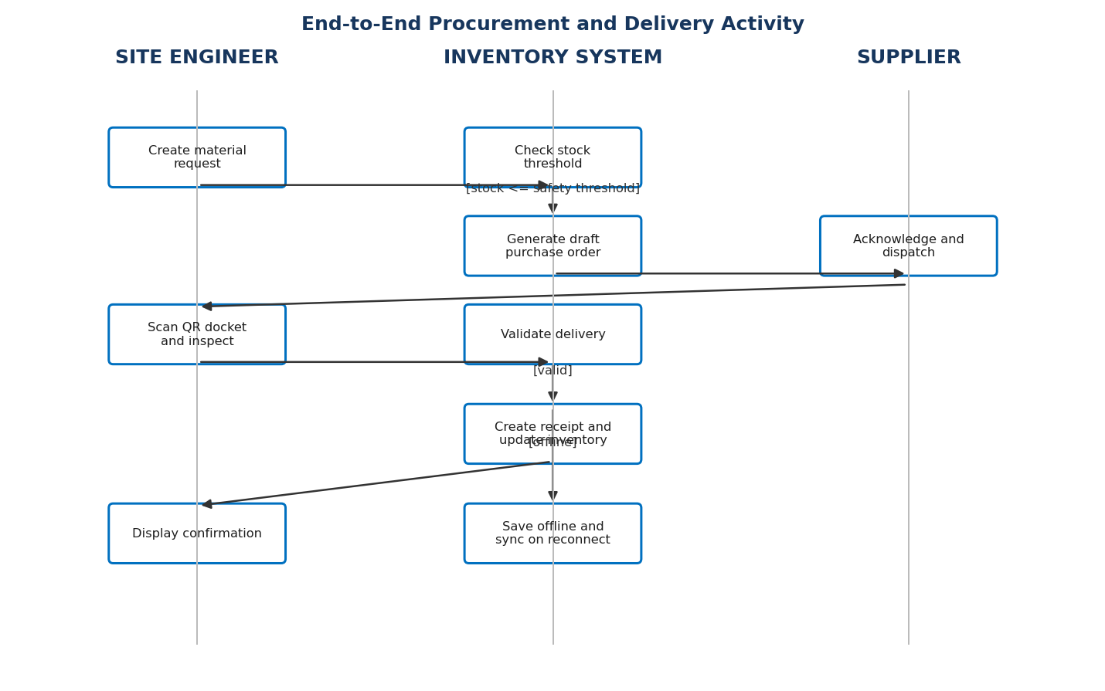
Figure 3. Multi-Swimlane Activity Diagram

8.2 Purchase-Order State Transition Diagram
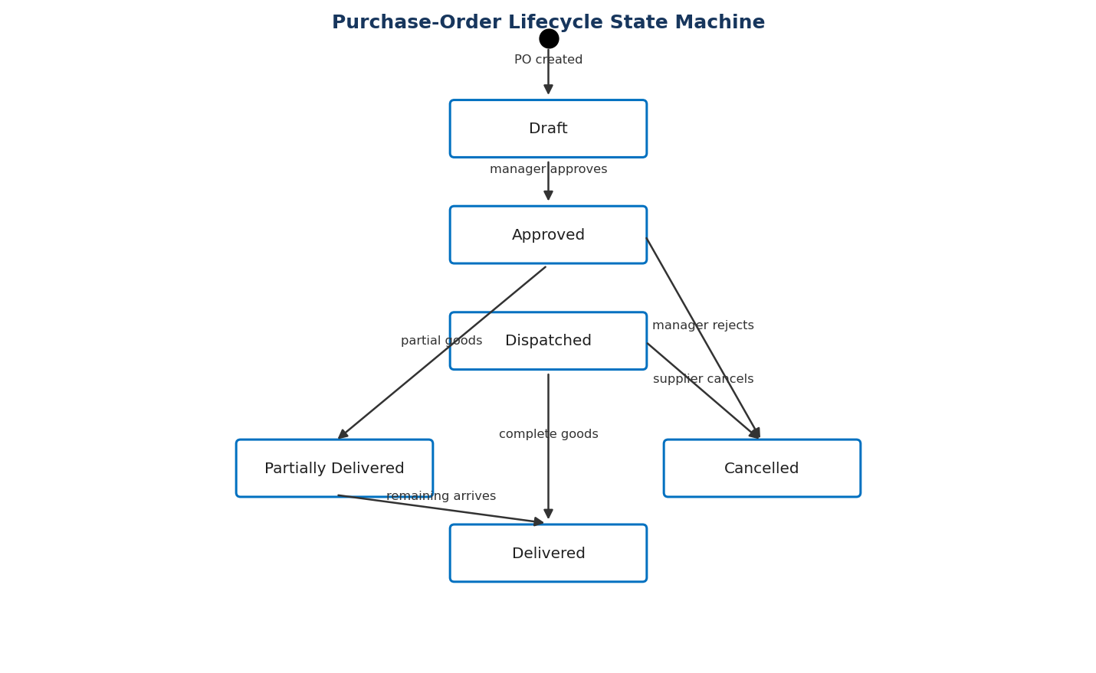
Figure 4. Purchase-Order Lifecycle State Diagram

8.3 System Sequence Diagram
This system-level sequence diagram treats the application as a black box and shows externally visible system events for UC-02.
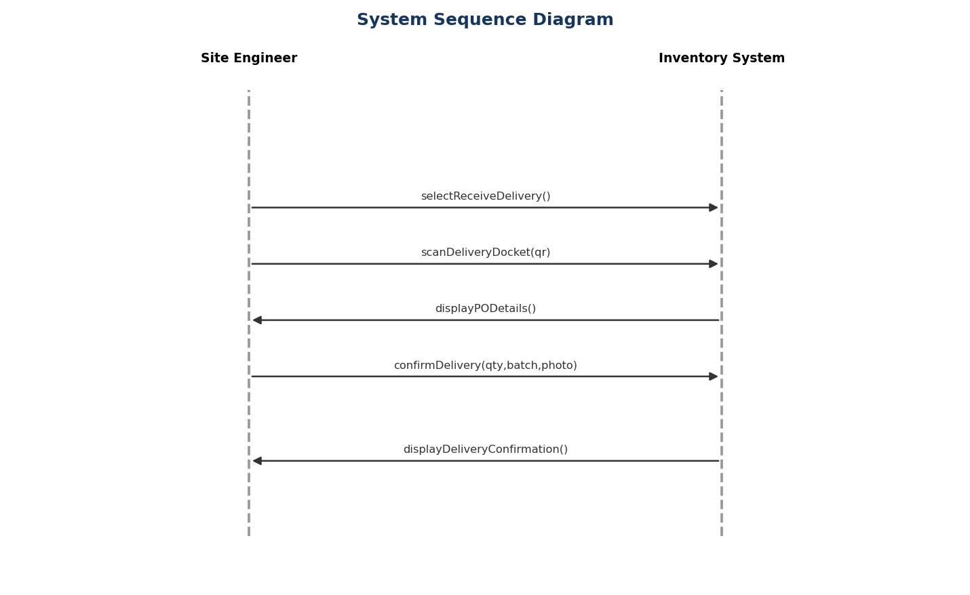
Figure 5. System Sequence Diagram for UC-02

8.4 Class/Object Sequence Diagram
This design-level sequence expands the system event into object interactions and identifies the class operations required to implement it.
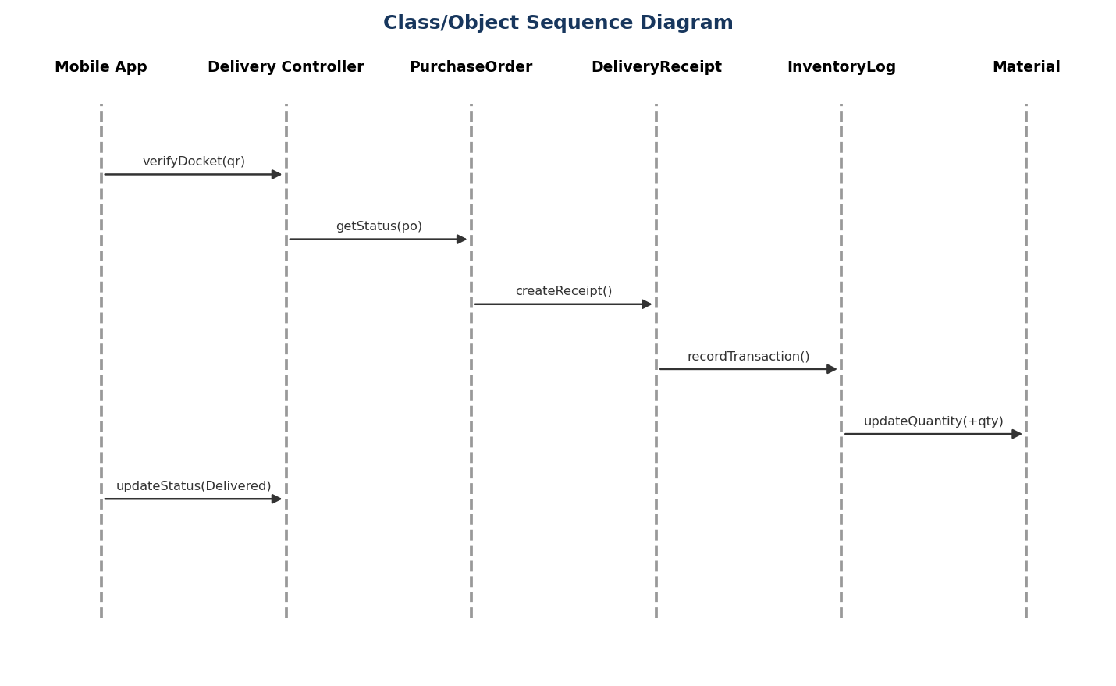
Figure 6. Class/Object Sequence Diagram for UC-02

9. Requirements Traceability and Class-Operation Mapping
Business Goal | Use Case | Domain Class | Sequence Operation | Architecture Layer | Test Case
BG-01 Wastage | UC-02 Log Delivery | DeliveryReceipt, InventoryLog | createReceipt(), recordTransaction() | Presentation / Application | TC-DEL-01
BG-02 Downtime | UC-04 Trigger Reorder | Material, PurchaseOrder | isBelowSafetyThreshold(), calculateReorderQuantity() | Application | TC-ORD-02
BG-03 PO Speed | UC-01 Request Material | SiteManager, PurchaseOrder | createPurchaseOrder(), approvePurchaseOrder() | Application | TC-REQ-03
BG-04 Accuracy | UC-03 Verify Stock | Material, InventoryLog | getCurrentBalance(), checkStock() | Persistence | TC-INV-04

9.1 Operation Derivation from the Class Sequence Diagram
Sequence Message | Responsible Class | Purpose
verifyDocket(qrCodeData) | DeliveryController | Validate the QR docket and identify the PO.
getStatus(poNumber) | PurchaseOrder | Confirm that the PO is eligible for receipt.
createReceipt() | DeliveryReceipt | Create a receipt for the delivered quantity.
recordTransaction() | InventoryLog | Record the inventory movement for auditability.
updateQuantity(+qty) | Material | Increase available quantity after validation.
updateStatus(Delivered) | PurchaseOrder | Move the PO to its Delivered lifecycle state.

9.2 Verification Scenarios
Test ID | Scenario | Expected Result
TC-DEL-01 | Valid QR docket and complete delivery | Receipt created, stock increased and PO becomes Delivered.
TC-DEL-02 | Offline delivery capture | Encrypted local record saved and synchronized within 30 seconds of reconnection.
TC-DEL-03 | Quantity above 105% of PO | Manager approval is required before stock is added.
TC-ORD-01 | Stock at safety threshold | Draft PO and low-stock alert are generated.
TC-ORD-02 | Order above $50,000 | Dual approval is required before supplier transmission.

10. Conclusion
The Smart Construction Site Material & Inventory Management System provides a complete software-engineering blueprint for controlling construction materials from request through delivery and stock reconciliation. The use-case model defines responsibilities, MoSCoW prioritization aligns delivery with business value, and the two detailed Cockburn-style specifications capture both functional and non-functional requirements. The three-tier architecture supports offline field operation, while the class, activity, state and sequence models establish a traceable design. The operation mapping demonstrates that class operations are derived directly from the class sequence interactions.

11. References
- Object Management Group, Unified Modeling Language (UML) Specification.
- Alistair Cockburn, Writing Effective Use Cases.
- SS ZG562 Software Engineering and Management assignment instructions.
- Project domain assumptions and requirements defined by the Site-Sathi group.

